PROJECT FOR THE IMPROVEMENT OF THE INFANT CENTER - RETOÑITOS

RESPONSIBLE:

Children's Center: Lic. Elvia Farinango -Coordinator Infant Center.
FEDICE: TMd. Blanca Puma - Executive Director

LOCATION:
Province: Imbabura
Canton: Otavalo
Parish: González Suárez
Community: Caluqui
Children's Center: "Retoñitos"

JUSTIFICATION
The children's center provides care to 40 children from the community. The problems of the children's center are: roof tiles and ceiling are in poor condition, leaking and humidity issues, lack of space in the dining room, and unsuitable chairs in the dining room.

GENERAL OBJECTIVE
Improve the infrastructure of the children's center.

SPECIFIC OBJECTIVES

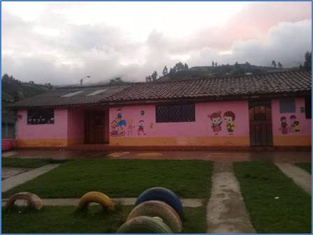
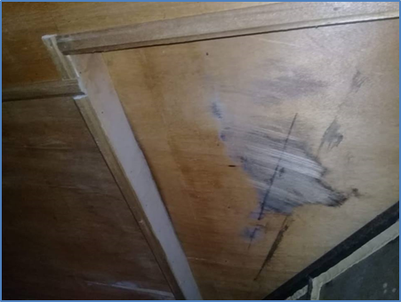
- Change the roof and ceiling that are in poor condition.

- Expand the dining area.
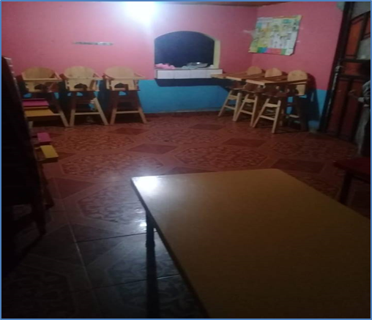

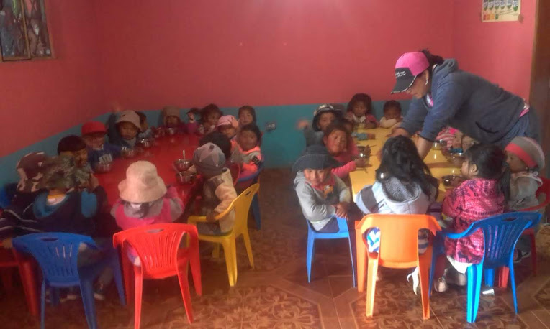

COST
PROJECT FINANCING
PARTICIPANTS | CONTRIBUTION | VALUE | %
Donation | Money: Materials + Follow – up FEDICE | 4.331,18 | 74%
Community | Labor | $ 1.550,00 | 26%
TOTAL FINANCING |  | $ 5.881,18 | 100%

The project costs $ 5,881.18. The community will contribute $ 1,550 (26%) to cover the cost of labor and food during work time. The remaining 76% ($ 4,331.18) will be financed by a donation.
REQUEST FOR NON-REFUNDABLE FUNDS
FEDICE requests $ 4,331.18 to invest in the reconstruction of the Infant Center Retoñitos. The funds will be invested as follows:
$ 3,796.53 for the purchase of materials to fix the roof and ceiling and $534.65 to cover costs of monitoring the work. Resources for materials will be delivered to the community as non-reimbursable funds.
ANNEXES
COST FOR THE IMPROVEMENT OF
THE "RETOÑITOS" CHILDREN'S CENTER

REF. | MATERIALS
 | QUANTITY | DETAIL | UNIT VALUE | TOTAL  VALUE
a) | 5.000 | Roof Tiles | 0,32 | 1.600,00
 | 500 | Strips | 0,34 | 170,00
 | 10 | Cement | 8,14 | 81,40
 | 125 | Staves | 1,48 | 185,00
 | 20 | Pounds of nails | 0,89 | 17,80
 | 3 | Painting | 42,86 | 128,58
 | 2 | Rollers | 2,5 | 5,00
 | 2 | Brushes | 4,24 | 8,48
 | 30 | Trolleys find sand | 1,25 | 37,50
 | 200 | Blocks | 0,3 | 60,00
 | 10 | Floor tile (m²) | 9 | 90,00
 | 2 | bondex | 11 | 22,00
 | 120 | Gipson plates decorated |  | 984,00
 | SUBTOTAL MATERIALS |  |  | 3.389,76
 | 12% IVA |  |  | 406,77
 | TOTAL OF MATERIALS |  |  | $ 3.796,53
b) | LABOR
 | 1 | Skilled Labor | 300 | 300,00
 | 5 | Mingas (Community work) | 100 | 500,00
 | 15 | Feeding | 50 | 750,00
 | TOTAL LABOR |  |  | $ 1.550,00
c) | TOTAL OF BUDGET = a) + b) |  |  | $ 5.346,53
d) | Follow-up FEDICE 10% de c) |  |  | $ 534,65
e) | TOTAL PROJECT OF IMPROVEMENT = c) +e) |  |  | $ 5.881,18

