PROJECT FOR ADAPTATION OF CHILDREN'S CENTER
"MUSHUK MUYU" (NEW SEED)

BACKGROUND

In the community of Tocagon, located in the parish of San Rafael (Canton Otavalo), the members of this community built a communal house in 2005. The house is used for meetings, talks, community celebrations, and other events.

In 2004, the mothers in the community recognized the need for a children’s daycare center. In 2010, the Nursery became the INNFA Institution (National Institute for Children and the Family) and became a Public Institution of the State as a Children's Center that works together with the San Rafael Parish Board. In 2013, the Children's Center became part of the MIES (Ministry of Economic and Social Inclusion) and became the Children's Centers of Good Living. It is currently operating as a daycare center named "MUSHUK MUYU".

JUSTIFICATION

At the beginning of the year 2018, a general diagnosis was made in the MUSHUK MUYU, infant daycare. The main problems found are unsanitary bathrooms with cracks in the floors and a dining room floor in poor condition.

The infant center has large classrooms in good condition.

GENERAL OBJECTIVE

Improve the infrastructure of the children's center to provide quality care to children under 3 years old in the Tocagon community.

BUDGET FOR REMODELING THE DINNING ROOM AND SANITARY BATTERIES
COST OF THE MATERIALS
a) | QUANTITY | DETAIL | UNIT VALUE | TOTAL
 | 7 | Tall doors | 112,00 | 784,00
 | 10 | Cement | 9,12 | 91,17
 | 3 | Paint | 48,00 | 144,01
 | 11 | Trolleys for fine sand | 1,40 | 15,40
 | 9 | Trolleys for heavy sand | 1,40 | 12,60
 | 9 | Gravel forklift | 1,40 | 12,60
 | 7 | Blocks of 10 | 0,28 | 1,96
 | 38 | Floor tile (meters²) | 10,08 | 383,04
 | 35 | Grey tile (35 m²) | 13,44 | 470,40
 | 5 | Porcelain | 5,04 | 25,20
 | 10 | Bondex plux | 14,56 | 145,60
 | 10 | Bondex | 12,32 | 123,20
 | 1 | Iron | 13,44 | 13,44
 | 3 | Boards | 1,68 | 5,04
 | 1 | Washbasin for dishes | 11,20 | 11,20
 | 1 | Tube | 17,92 | 17,92
 | 4 | Elbows of ½ | 3,36 | 13,44
 | 1 | Wrench for the washbasin | 8,96 | 8,96
 | 8 | Porcelain | 5,60 | 44,80
 | 2 | Wire | 168,00 | 336,00
 | TOTAL |  |  | 2.659,98

b) | COST OF LABOR | 500,00
c= a+ b | TOTAL FOR REMODELING | 3.159,98
d) | FEDICE FOLLOW- UP 10% de c) | 316,00
e)= c + d | TOTAL ADJUSTMENT PROJECT | 3.475,98

REQUESTED DONATION
FEDICE requests a donation of $ 2,975.98 to be used to purchase materials ($ 2,659.98 worth) and cover the cost of tracking the work by FEDICE ($316).
The community will contribute $ 500 for labor and they will also contribute labor themselves.

WORK NEEDED IN DINING ROOM
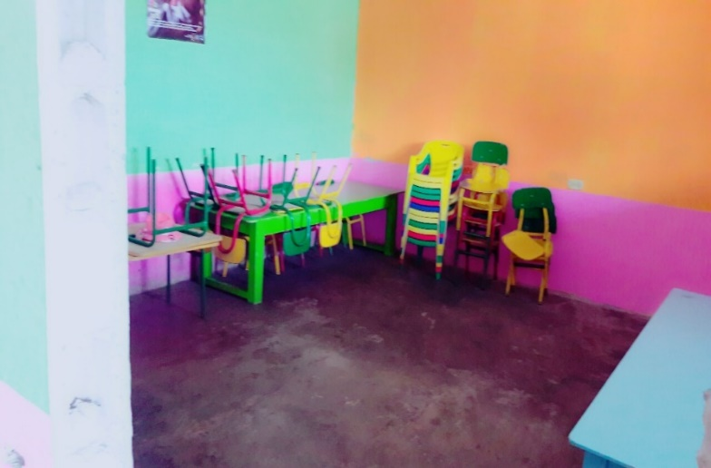
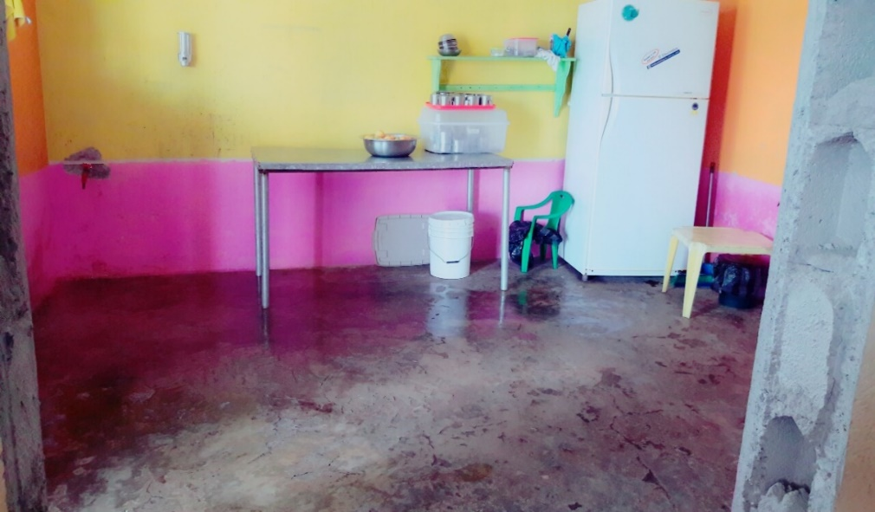

DOORS NEEDED IN THE BATHROOMS

